Cross Sun Catcher
Materials
- 2 paper plates
- Scissors
- Pencil
- Glue stick
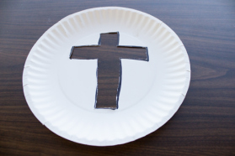
- Tissue paper
- Felt Tips

Step 1: Draw the shape of a cross on the
first paper plate and cut it out.

Step 2: Laying the paper plate with the cross on
top of the other plate, carefully trace around the
inside of the cross and cut this one out as well.
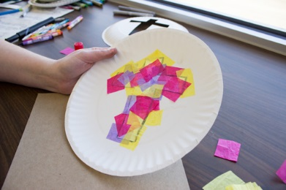
Step 3: On one of the paper plates, glue little
squares of tissue paper. Make sure the cross
opening is completely covered.
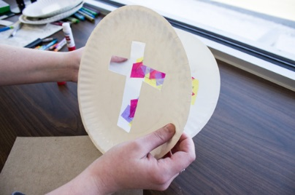
Step 4: Glue the other paper plate on top of
the paper plate with the tissue paper.
Make sure to line up the two crosses.

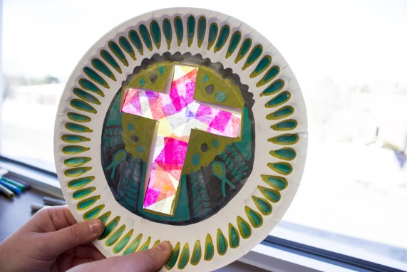
Step 5: Colour as desired.

